

AICT-Lab
Final’s Project
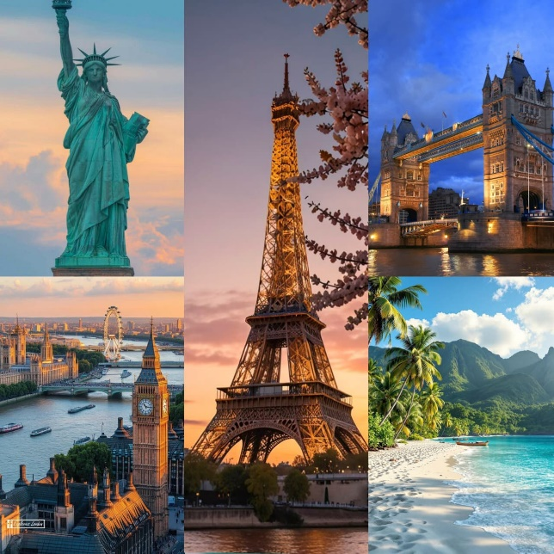
Dream Travel Agency

Submitted to | Ms. Ramsha Khalid
Submitted by: | - Abu Bakar 2025-GA-99  - Tahira Najeeb 2025-GA-110  - Laiba Maqbool 2025-GA-101  - M. Faiq 2025-GA-61  - Fatima Waheed 2025-GA-88  - Qudsia 2025-GA-69



Table of Contents

Executive Summary 3
Introduction 3
➢ Show Popular Tourist Spots: 3
➢ Offer Diverse Travel Packages 3
➢ Manage Financial Records: 3
➢ Organize Travel Services: 3
➢ Enable Customer Interaction 3
Scope of the Project 3
Site structure & Navigation 4
Travel Itinerary & Brochure 5
TRAVEL AGENCY PACKAGES 7
1. LUXURY PACKAGE 7
2. STANDARD PACKAGE 7
Balanced comfort & affordability 7
3. ECONOMY PACKAGE 7
MS EXCEL 8
9
How to Run / Publish 10
➢ Local Viewing 10
➢ Data Updates: 10
Learning objectives: 10
Future Improvements 10
• Dynamic Integration 10
• Interactive Dashboard 10
• Online Booking & Payments 10
• Enhanced Visuals 10
GitHub 10
Live project links 11
https://laibamaqbool123.github.io/group-no-2-Dream-travel-agency/ 11
https://qudsiarizo24-hash.github.io/AICT-Final-Pro/ 11
https://tahirabutt.github.io/TravelAgency/ 11
https://fatimahwaheed158-alt.github.io/group-no-2-Dream-travel-agency/ 11
https://itxabbutt-hash.github.io/group-no-2-Dream-travel-agency 11
Power Point 11
Animated Video 11
Linkedln 11
Conclusion 12
Suggestions 12




Exploria travels

Executive Summary
The project centers on the Development of a Website on Travel and Tourism for Dream Travel Agency, developed for the AICT Lab semester project. This would mainly involve applying concepts in web development to practically present travel services on a clean and user-friendly digital platform.
The site offers the possibility of surfing different foreign locations, browsing the available tour packages, and knowing about the facilities provided by Exploria Travels. The critical sections of the website are Home, About, Destinations, Packages, and Contact, which ensure the smooth flow and clear communication of information. The agency offers tourist travels to many countries like Germany, Italy, Turkey & UK etc. to the leisure, honeymoon, and family travelers.

Introduction
As the use of digital platforms picks pace, it has now become indispensable for travel agencies like those of Exploria Travels to have an effective online presence in order to connect with their clients. A good website enables tourists to explore, compare, and access agencies appropriately. Exploria Travels seeks to address this aim through developing an effective website for its clients.
Project Objectives

Show Popular Tourist Spots:
Show detailed information on selected countries, emphasizing tourism attraction, cultures and their appeal.
- Offer Diverse Travel Packages:
Launch various travel plans such as Luxury Tours Packages, Budget Trips Packages, Honeymoon Packages, Family Vacation Packages.
- Manage Financial Records:
Track package rates, booking frequency, and monthly earnings through Excel-based calculations.
- Organize Travel Services:
Classify packages into Luxury and Standard categories to meet different customer preferences.
- Enable Customer Interaction:
Provide contact and inquiry options to assist customers with bookings and travel-related questions.

Scope of the Project
- The process of building a professional website for a travel agency like Exploria Travels
- Presentation of international travel destinations for selected countries
- Displaying several travel packages such as Luxury Budget, Honeymoon, and Family packages
- Better Definition of Services to Enhance Consumer Comprehension
- Friendly menu system throughout the entire site
- Inclusion of necessary pages like Home, About, Destinations, Packages, and Contact
- Provision of Basic Customer Inquiry and Booking Services

Site structure & Navigation
The site, Exploria Travels, has been organized into distinct pages that give users an easy chance to navigate their choices of places to visit. Each country page includes the major attractions that users may take advantage of.
Page | Purpose
index.html | The homepage featuring a hero section, highlighted destinations, and a call-to-action for travel inquiries and bookings.
destinations.html | An overview page listing all international destinations offered by Exploria Travels.
indonesia.html | Showcases tropical islands, rich cultural heritage, and famous attractions such as Bali, making Indonesia ideal for nature and beach lovers.
uk.html | Highlights historic landmarks, modern cities, and cultural diversity across England, Scotland, and Wales.
usa.html | Features iconic cities, entertainment hubs, and diverse landscapes, offering a wide range of travel experiences.
france.html | Focuses on romantic destinations, world-famous landmarks, and rich art and culinary culture.
turkey.html | Showcases a blend of history and culture with famous sites such as Istanbul, Cappadocia, and ancient monuments.
canada.html | Highlights natural beauty, scenic landscapes, and vibrant cities known for a peaceful travel experience.
maldives.html | Focuses on luxury resorts, crystal-clear waters, and honeymoon-focused travel experiences.
thailand.html | Features beautiful beaches, cultural temples, and affordable travel options popular among tourists.
packages.html | Displays categorized travel packages including Luxury, Budget, Honeymoon, and Family tours.
contact.html | Customer support and inquiry page for booking assistance and travel-related questions.

Travel Itinerary & Brochure
Destination | Image | Highlight
Indonesia | 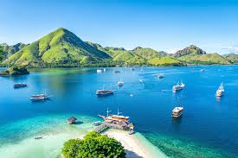 | Bali beaches, cultural tours, tropical islands
UK |  | Historic landmarks, London city life
USA |  | NYC, Grand Canyon, entertainment hubs
France |  | Paris romantic tours, art & cuisine
Turkey | 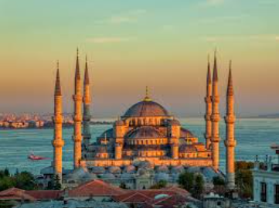 | Istanbul, Cappadocia, ancient monuments
Canada |  | Scenic landscapes, Niagara Falls
Maldives | 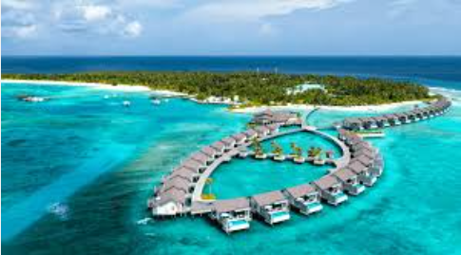 | Luxury resorts, crystal-clear waters
Thailand |  | Beaches, temples, affordable tours

TRAVEL AGENCY PACKAGES

1. LUXURY PACKAGE
- For clients who want comfort, class & unforgettable experiences
- 5-star hotels or resorts
- Business / Premium Economy flights
- Private airport transfers
- Daily breakfast + 2 luxury dinners
- City tours with private guide
- VIP sightseeing & skip-the-line access
- Cruise / yacht experience (if available)
- Spa, wellness & shopping tour
- Travel insurance
- 24/7 personal travel assistant
- Perfect for honeymooners, celebrities, and luxury lovers.

2. STANDARD PACKAGE

Balanced comfort & affordability
- 3–4 star hotels
- Economy class flights
- Airport transfers
- Daily breakfast
- Group sightseeing tours
- City & cultural tours
- Entry tickets to major attractions
- Professional tour guide
- Travel insurance
- Customer support

3. ECONOMY PACKAGE
- Best for budget travelers
- Budget hotels or hostels
- Economy class flights
- Shared airport transfer
- Selected sightseeing tours
- Free day for shopping/exploring
- Tour guide (group)
- Basic travel assistance
- Best for students, solo travelers & backpackers.
- If you want, I can also:
- Add prices
- Customize it for Pakistan, Turkey, UK, Dubai

MS EXCEL
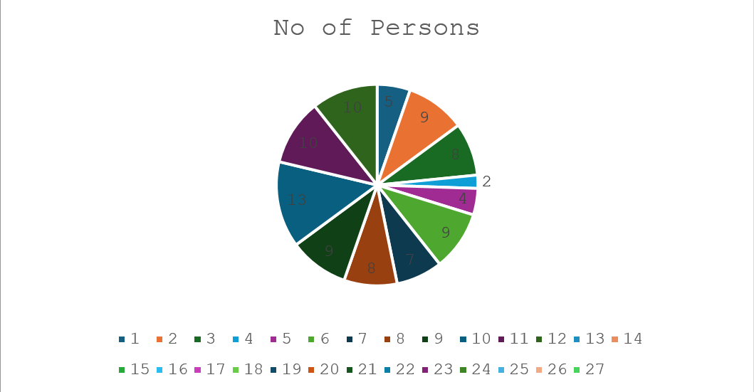

This chart shows the distribution of the number of persons included in the survey, highlighting how frequently each group size appears.
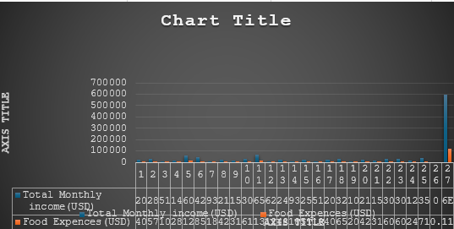

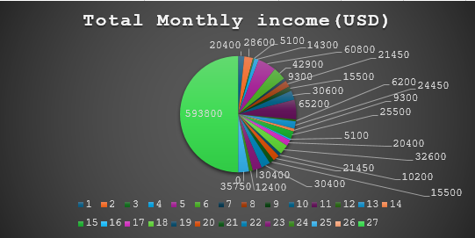
This chart compares total monthly income with food expenses, showing the difference between earnings and spending for each category.

This chart illustrates the proportion of total monthly income in USD, showing how income is distributed among different entries.
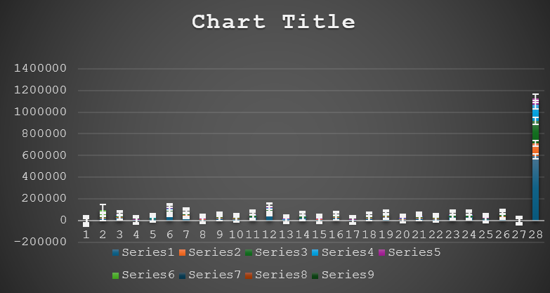

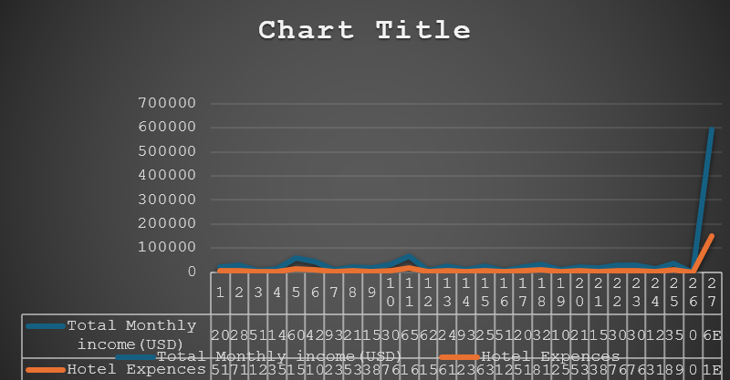
This chart presents a comparison of multiple data series, showing variations across different categories over time.

This chart shows a comparison between total monthly income and food expenses, highlighting changes in income and spending patterns.
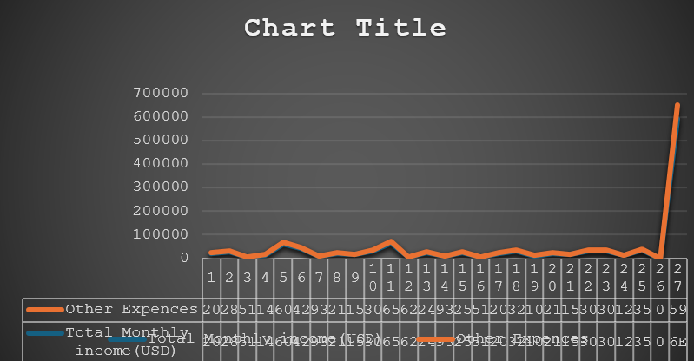

This chart compares other expenses with total monthly income, indicating how additional costs relate to overall earnings

How to Run / Publish

- Local Viewing:
Make sure all the files of your website, like HTML files, CSS files, and image files, are stored in the same directory. You can view your website by opening the `index.html` file using any modern web browser of your choice.

Data Updates:
Travel packages, destinations, and specials can be updated in the files of the website itself. If there are modifications made in package information, rates, or package availability, it should be manually updated by altering the corresponding HTML pages.

Learning objectives:
This project reinforced the need to pair a pleasing front-end with well-organized content. Organizing pages for individual countries and travel packages allows customers to easily locate what they need, and presenting information about a travel package in an easily viewed manner allows customers to make sound judgments about where they would like to travel. The project further reinforced skills in website layout and navigation.

Future Improvements
- Dynamic Integration: Connect the website to a database to manage travel packages, availability, and pricing in real-time.
- Interactive Dashboard: Add an admin panel that displays booking trends, popular destinations, and package performance visually.
- Online Booking & Payments: Implement secure online booking and payment options for customers.
- Enhanced Visuals: Include interactive maps, slideshows, and videos to make the website more engaging.

GitHub
I have created a GitHub repository to manage and organize my projects efficiently. Recently, I pushed all my AICT lab tasks to this repository, ensuring proper version control and documentation. This allowed me to maintain a structured workflow while keeping track of all submissions in one place. Through this process, I gained hands-on experience with Git commands, repository management, and collaborative coding practices. Maintaining these tasks on GitHub has improved my technical skills, enhanced my coding discipline, and allowed me to showcase my work professionally.

Live project links

https://laibamaqbool123.github.io/group-no-2-Dream-travel-agency/

https://qudsiarizo24-hash.github.io/AICT-Final-Pro/

https://tahirabutt.github.io/TravelAgency/

https://fatimahwaheed158-alt.github.io/group-no-2-Dream-travel-agency/

https://itxabbutt-hash.github.io/group-no-2-Dream-travel-agency

Power Point
Our project is based on a website created for Dream Travel Agency, where we provide complete details about all the travel facilities and packages offered by our agency. In this presentation, we have explained different travel classes and price ranges so that customers can easily choose a package according to their budget and preferences. The website highlights services such as flight bookings, hotel reservations, guided tours, transportation, and customized travel plans. Each package is designed to give customers comfort, convenience, and value for money. Through this presentation, we aimed to show how Dream Travel Agency helps travelers plan memorable and well-organized trips with reliable and affordable services.

Animated Video
Our project is based on a website created for Dream Travel Agency, where we provide complete details about all the travel facilities and packages offered by our agency. In this presentation, we have explained different travel classes and price ranges so that customers can easily choose a package according to their budget and preferences. The website highlights services such as flight bookings, hotel reservations, guided tours, transportation, and customized travel plans. Each package is designed to give customers comfort, convenience, and value for money. Through this presentation, we aimed to show how Dream Travel Agency helps travelers plan memorable and well-organized trips with reliable and affordable services.

Linkedln
We also shared our Dream Travel Agency project on LinkedIn to highlight the work we completed as a team. In our post, we uploaded all the components of the project, including the website created using HTML, the Excel work, the animated video, the Word documentation, and the Git repository. This post was made to showcase our learning, teamwork, and project development process. We also tagged our teammates, our TA, and the department to acknowledge their guidance and support. Sharing this project on LinkedIn helped us present our skills and efforts in a professional way while staying connected with our academic community.

Conclusion
In conclusion, our Dream Travel Agency project allowed us to combine creativity, technical skills, and teamwork to design a complete travel service concept. Through our website, PowerPoint presentation, animated video, Word documentation, Excel work, and Git repository, we presented our agency’s facilities, travel classes, and price-based packages in a clear and professional way. Sharing the project on LinkedIn further helped us showcase our efforts and growth as students. Overall, this project not only improved our technical learning, but also strengthened our communication, collaboration, and presentation skills.

Suggestions
• Add interactive features to the website, such as:
- Online booking system
- Customer feedback and reviews
- Live chat support
• Provide detailed price breakdowns and comparison tables so customers can easily choose the best package.
• Improve the animated video by adding real-life travel scenarios and customer experience examples.
• Keep the Git repository regularly updated for proper version control and clear project documentation.
• Promote the project more actively on LinkedIn and other platforms to reach a wider audience and gain useful feedback.
• Add security features for online payments and customer data protection.
• Include FAQs and travel guidance to help customers make informed decisions.

